For this assignment, write queries using SQL to acquire data about customers, vendors, products, and employees in a fictitious sales database. These queries will cover many of the core aspects of writing SQL to produce data for reporting and analyzing information. There may be multiple ways to produce the same results, but ensure you are returning the requested fields.

Using the Sales Orders database, complete the queries below.

1. **Show all the information on our customers**.
2. Query:

SELECT * FROM customers;

1. Columns: CustomerID,CustFirstName,CustStreetAddress,CustCity,CustState,CustZipCode,CustAreaCode,CustPhoneNumber.
2. Expected Row Count:28
3. Screenshot:

1. **Show a list of states, in reverse alphabetical order, where our vendors are located, and include the names of the vendor.**
2. Query:

Select VendName,VendState

FROM salesorders.vendors

ORDER BY VendState DESC

1. Columns:

2

1. Expected Row Count:

11

1. Screenshot:

1. **What if we adjusted the retail price of each product by increasing it 7 percent?**
2. Query: SELECT ProductName,RetailPrice,RetailPrice * 1.7 FROM products;
3. Columns: 3
4. Expected Row Count:40
5. Screenshot:

1. **Show a list of orders made by each customer in ascending date order.**
2. Query:

SELECT OrderDate,OrderNumber,CustomerID

FROM orders

ORDER BY OrderDate ASC;

1. Columns:

3

1. Expected Row Count:

944

1. Screenshot:

1. **Give the names of all vendors based in Albany, Anchorage, and Dallas.**
2. Query:

SELECT VendName,VendorID,VendCity FROM vendors WHERE VendCity IN ('Albany','Anchorage','Dallas')

;

1. Columns:

3

1. Expected Row Count:

3

1. Screenshot:

1. **Show an alphabetized list of products with a quantity on hand greater than or equal to 30.**
2. Query:

SELECT ProductName,QuantityOnHand FROM products

WHERE QuantityOnHand >= 30 ORDER BY ProductName;

1. Columns:

2

1. Expected Row Count:

9

1. Screenshot:

1. **What vendors do we work with that don’t have an email address?**
2. Query:

SELECT * FROM vendors

WHERE VendEMailAddress IS NULL;

1. Columns:

10

1. Expected Row Count:

5

1. Screenshot:  
   Graphical user interface, table

   Description automatically generated
2. **List employees and the dates their orders shipped sorted by order date.**
3. Query: SELECT OrderDate,ShipDate

FROM orders

ORDER BY OrderDate;

1. Columns: 2
2. Expected Row Count:

944

Screenshot:

1. **Show the vendors and products they supply to us for products over $75 for vendors in Texas.**
2. Query:

SELECT VendState,RetailPrice

FROM vendors,products

WHERE RetailPrice >75

ORDER BY VendState DESC, RetailPrice;

1. Columns: 2
2. Expected Row Count:

198

1. Screenshot:

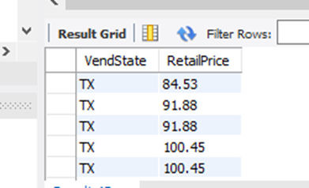

1. **Show employees who live in the same city and state as our vendors.**
2. Query:

SELECT concat(EmpFirstName, ' ', EmpLastName) as Name,EmpState,EmpCity FROM employees

WHERE EmpCity in (SELECT VendCity from vendors)

and EmpState in (SELECT VendState from vendors);

1. Columns:

3

1. Expected Row Count:

2

1. Screenshot:

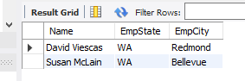

1. **Display customers who have no sales rep (employees) in the same state.**
2. Query:

SELECT concat(CustFirstName, ' ', CustLastName) as Name,CustState From customers

WHERE CustState not in ( SELECT EmpState From employees);

1. Columns:

2

1. Expected Row Count:

11

1. Screenshot:

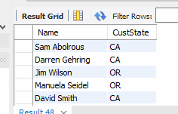

1. **What is the average quoted price of a helmet?**
2. Query:

Select ProductName, FORMAT(AVG(RetailPrice), 2) from products WHERE PRODUCTNAME LIKE '%helmet%';

1. Columns:

2

1. Expected Row Count:

1

1. Screenshot:

1. **What was the date of the earliest ship date?**
2. Query:

select min(shipDate) FROM orders;

1. Columns:

1

1. Expected Row Count:

1

1. Screenshot:

1. **What is the total amount (in dollars) of orders from the state of Oregon?**
2. Query:

SELECT FORMAT(sum(OrderTotal), 2), CustState

FROM orders

left join customers

on orders.CustomerID = customers.CustomerID

WHERE CustState = 'OR';

1. Columns:

2

1. Expected Row Count:

1

1. Screenshot:

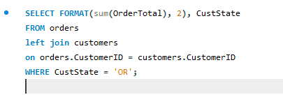

1. **Show each employee, the employee’s total sales (in dollars), the employee’s total sales item quantity, and the average item sales price ordered by the employee’s average item sales price highest to lowest.**
2. Query:

SELECT EmpFirstName,sum(OrderTotal), avg(QuotedPrice), sum(QuantityOrdered)

FROM order_details

LEFT JOIN orders

on order_details.OrderNumber = orders.OrderNumber

LEFT JOIN employees

on employees.employeeID = orders.EmployeeID

group by EmpFirstName

order by QuotedPrice

1. Columns:

4

1. Expected Row Count:

8

1. Screenshot:

